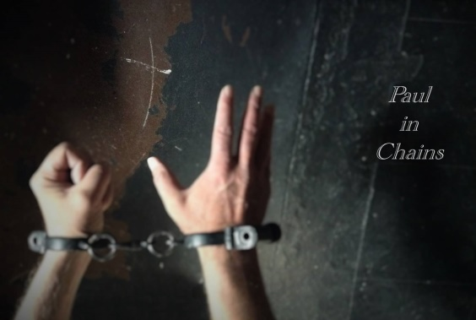

Paul in Chains

Please reflect and respond:
- What did you experience in this presentation today?
____________________________________________________________
____________________________________________________________
____________________________________________________________
____________________________________________________________
- How did God speak to you through Paul? What will you take away from hearing God’s word today?
____________________________________________________________________________________________________________________________________________________________________________________
Name (optional) _____________________________________

If you or someone you know would be interested in this drama ministry to be presented to another church or group please contact Duffy Roberts.
Pick up a business card as you leave.
www.paulinchains.com RevDuffyRoberts@gmail.com

Paul in Chains

Please reflect and respond:
- What did you experience in this presentation today?
____________________________________________________________
____________________________________________________________
____________________________________________________________
____________________________________________________________
- How did God speak to you through Paul? What will you take away from hearing God’s word today?
____________________________________________________________________________________________________________________________________________________________________________________
Name (optional) _____________________________________

If you or someone you know would be interested in this drama ministry to be presented to another church or group please contact Duffy Roberts.
Pick up a business card as you leave.
www.paulinchains.com RevDuffyRoberts@gmail.com

