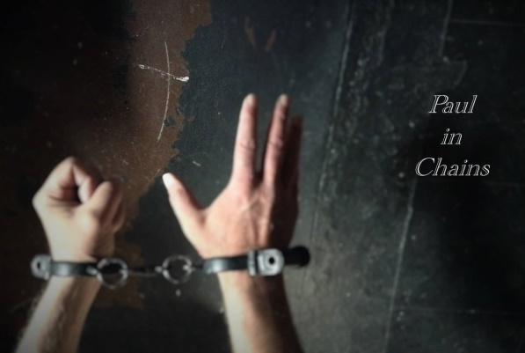
I am sure you have never experienced the Scriptures in quite this way before. I work hard to portray the Apostle Paul as a real person with intense passion, deep emotion and clear thought. The presentation is up close, personal, powerful and prayerful.
My needs for presenting “Philippians” are quite simple and very adaptable to any setting or venue.

What I am asking for:
- A lapel microphone or over-ear-microphone for any gathering larger than 25 or 30 people.
- A “host” or group leader who will introduce the presentation with some suggested remarks and conclude the presentation with appropriate prayer and reflection. I will meet with this person for 10 minutes at least one hour beforehand.
- A volunteer actor who will play the role of the Prison Warden. He/She will adapt and read from a script which provides the historical back story of the Apostle and sets the scene for the audience. I will meet with this person for 10 minutes at least one hour beforehand. No costume is required.
- A volunteer actor who will play the role of a Roman guard. He has no lines to speak. He simply escorts Paul in and then interrupts Paul to lead him out. I will meet with this person for 10 minutes at least one hour beforehand. I ask that he wear a simple black t-shirt and jeans and I will provide a simple costume piece.
- Urge all members of the congregation to fill in the front seats and sit closely together. Please rope off the back pews and seats. The idea is to create as intimate an environment as possible. My personal goal is to make direct eye contact with each person in the room at least once and draw him/her into the experience. I have often suggested not using the sanctuary or pews at all. We can create a great atmosphere by setting up chairs in the parlor or the church’s fellowship hall. Crowded is good, cozy is better. I often present “in the round” with people seated all about me. I need very little floor space.
- The presentation, including the introduction, takes less than 30 minutes.
- (Optional) If there is to be congregational singing you might consider preceding the introduction with “Break Every Chain” by Will Reagan. And I recommend closing with “Knowing You, Jesus (All I Once Held Dear)” by Graham Kendrick or some other suitable hymn or song.
- A display table where I can place promotional materials in case anyone would like to recommend my ministry to their friends or other churches.
- I require travel expenses to and from any venue beyond 25 miles from my home in Austintown, Ohio.
- An appropriate honorarium for the size of your gathering. I do not have a set fee. I will gladly accept a love offering if that is appropriate for your gathering. (In the past I have accepted $50 from smaller gatherings of 15 to 20 and up to $500 from larger, more affluent groups larger than 300. I simply trust the Lord to sustain me and this ministry.) If you have severely limited resources, let’s talk.
- Lastly, I ask for a written response from the host telling me of your and your congregation’s response to my presentation, including any constructive feedback, testimonials, and reflections. I reserve the right to quote you and name you in future promotional materials. This written feedback can be emailed to me within the week after the event.

On my web site www.paulinchains.com/philippians-prep-promo you can also find the following resources:
- A suggested bulletin announcement which you may adapt for promoting the event.
- A PowerPoint slide which you can project during promotional announcements and during the presentation.
- Suggestions for the host with talking points which can be adapted or read to the congregation.
- The script and instructions for the Prison Warden
- A reflection/response form which you can reproduce and hand to people. The host will encourage people to write down their personal reactions and experiences immediately after the conclusion of Paul’s remarks. And lead the gathering in reflective prayer. The host can gather the forms afterward and read them if they desire. I ask that they be forwarded to me to use in gauging the impact of the ministry and for future promotional purposes.

Any questions? Contact me directly: RevDuffyRoberts@gmail.com or 330-503-4214
Thank you for allowing me to offer God’s word to your people in this way.

In Christ,
Duffy Roberts

